**Website Design Template**

1.

<http://demo.cssmoban.com/cssthemes5/cpts_1609_crm/index.html>

颜色让人觉得很舒服

2.

<http://demo.cssmoban.com/cssthemes5/cpts_1050_box/index.html>

footer和navigation bar 我觉得不错，颜色可以换一下

3.

<http://demo.cssmoban.com/cssthemes3/tpmo_485_rainbow/index.html>

这个可以用在curriculum其中一个年龄段，也可以不用

4.

<http://demo.cssmoban.com/cssthemes3/cpts_205_cxy/index.html>

比较简洁

5.

<http://demo.cssmoban.com/cssthemes1/ftmp_18/index.html>

设计的非常“幼儿园”，比较有趣，但是不够简洁

我最喜欢模版1，其他的也可以借鉴，主体颜色偏向几种蓝色绿色黄色（我喜欢99CC33，FFCC00，也可以在上面的模版里找颜色），蓝色有些冷，可能绿色更适合幼儿园。颜色搭配网站：<https://tool.c7sky.com/webcolor/>

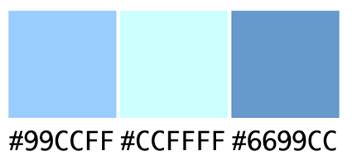

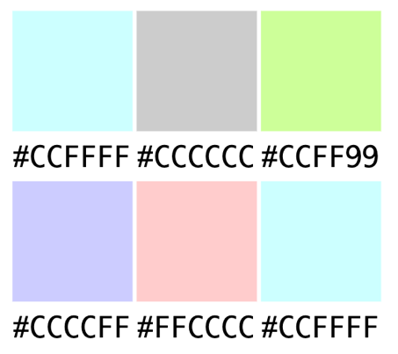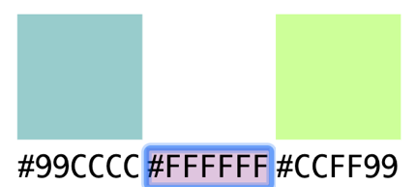

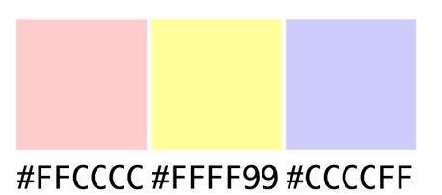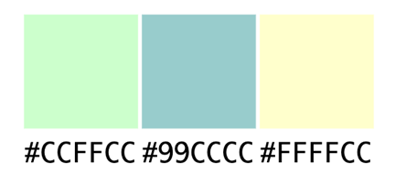

|  |  |  |  |  |  |
| --- | --- | --- | --- | --- | --- |
|  | 1 | 2 | 3 | 4 | 5 |
| Pros | Neat and fancy animation | Colourful nav bar, nice colorful sections in “about us” | Nice muted color combinations | neat | Cool bg, fonts |
| Cons | animation played too fast, “our feature” section may require additional work | no intro/welcome text | The only useful part is the bg img | too much white space | not as neat |
| Reusable sections | * Welcome animation * bg-img + kids-img section * gallery animation * bg-imgs | * Nav-bar * colourful section in “About us’ our activities” * Footer | / (the colour does not seem to fit other templates/fb-page) | / (I think 1&2 are better than 4 in general) | * welcome animation * nav-bar * recent-project section (probably not needed tho) * Footer |